**Factors**

When two numbers are multiplied to get a third number, the two numbers are factors.  
Consider: **a x b = c** ,    **a** and **b** are factors of **c**. **c** is referred to as the **Multiple**.  
A **composite number** is a number with more than two factors.

**Factors of Composite numbers**

a) Write all the factors of 32  
b) Express 32 as a product of two factors in 3 ways

a) Factors of 32 are:  
1, 2, 4, 8, 16, 32  
  
b) 24  
   = 1 x 32  
   = 2 x 16  
   = 8 x 4

**Prime Factors**

A prime number is a whole number greater than 1 that cannot be made by multiplying other whole numbers.  
E.g 2, 3, 5, 7, 11, 23.  
a) Write 120 as a product of it's prime factors in power form.

120  
   = 2 x 60  
   = 2 x 2 x 30  
   = 2 x 2 x 2 x 15  
   = 2 x 2 x 2 x 3 x 5  
   = 23 x 3 x 5

The above example can be presented using the **factor tree method**

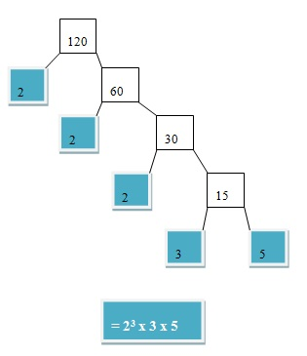

b) Expand and find the value of 24 x 72 x 11

24 x 72 x 11  
   = 2 x 2 x 2 x 2 x 7 x 7 x 11  
   = 16 x 49 x 11  
   = 8624